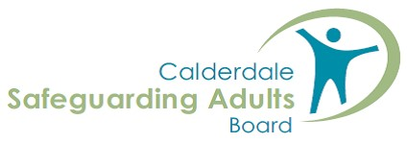
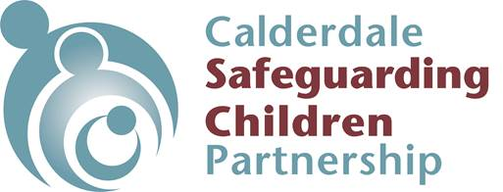
Domestic Abuse
The Importance of Language
A guide for Calderdale professionals on how we use language when identifying and responding to domestic abuse
Domestic abuse is all too common in Calderdale. Although the majority who experience domestic abuse are women, men and children can also experience it. Domestic abuse occurs in all types of intimate ex/partner or familial relationships, regardless of age, gender, ethnicity, sexuality or length of partnership. Certain factors such as poverty or ethnicity can then compound the impact of domestic abuse.
Effective practice and positive outcomes for individuals and families relies on trusted relationships and on a good understanding of the nature of domestic abuse. The language we use is key to developing trusting relationships, partnering with people and understanding their experiences. It has the power to support safety and a sense of agency and move away from blame. Language supports a trauma-informed response which, in turn supports trust. It also helps us avoid unintentional collusion with those using abusive behaviour.
The language we use is shaped by our own life experiences, cultures, work, personal environments and the media, amongst other things. It is helpful to develop our self-awareness around our values and influences and how these may emerge in our work, through language. Similarly, our professional role and organisational remit may require us to use language in a range of ways and situations. The aim of this guide is to provide a context and point of reference and reflection, whilst recognising there may need to be some adaptations to fit organisational need.
Communication is a two-way process. It may be necessary to check out the meaning of words with people, to avoid misunderstanding or misinterpretation. The same word may carry a different meaning to someone else. Trauma and fear may affect the words people use with us. The words we use may not be how people wish to be identified. Stay curious and don’t assume! Keep it simple.

Space for Action
Before we as professionals move into action, it is important to consider what space the person experiencing the abuse has for action. Remember, we and they can only move if there is space to do so. So, it can be helpful to put yourself in the person’s shoes and think:
- “What would ‘X’ need that would help increase safety and take some steps forward with me?”
- “What is important to X at this point (rather than what is important for X)?”
- “What freedoms and restrictions do they have?”
Understanding and meeting immediate need gets a foot on the ladder of progress
Women’s Aid developed a model to support the thinking for any individual:
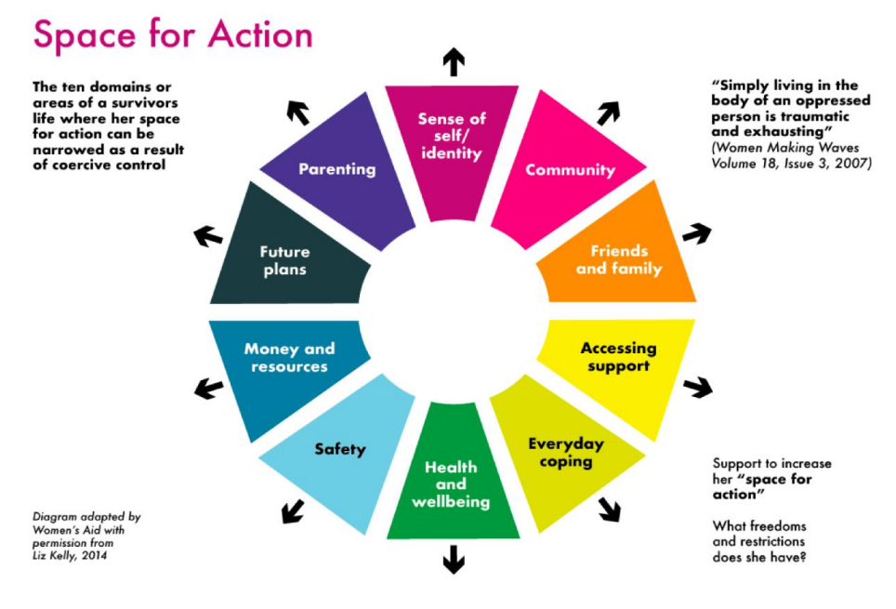
When using this “space for action” framework, consider:
- The presence of coercion and the lack of choice and control that survivors (and children) endure in abusive situations
- The repetitive and enduring impact of abusive controlling tactics, emotionally and physically
- The shame and guilt that many people who have experienced abuse carry, messages embedded by those carrying out the abuse
- The fear of being blamed by professionals and how this strengthens the power and control of the person carrying out the abuse
- The person at greatest risk of harm (short, medium and long-term) – the historical and current patterns of behaviour that erode confidence, self-esteem and impact on decision-making.

Framing questions – and avoiding inference of blame:
Asking someone “why” or “why not?” can feel particularly hard for people as it immediately feels accusatory and blaming, even if that is not the intention.
Examples of Constructive questions (supporting survivors) vs Destructive questions (inferring blame):
- What do you think would happen if you tried to leave? Vs Why don’t you leave?
- What would the consequences have been if you hadn’t answered the door/let “Y” in? vs “Why did you let Y back in?
- What happens if you don’t answer “Y” texts or calls? vs Why are you answering their texts/calls?
- What happened last time you called the police that made you feel it wasn’t a safe option this time?vs Why didn’t you call the police?

Describing and recording the abuse
If we can frame our recording and conversations in terms of the context of the abuse/the person carrying out the abuse, this can help us better assess and understand:
- The context in which survivors are making decisions – choice is often not realistic
- The impact of the abuse and the associated trauma on their decision-making
- The reasons why survivors, including children, respond the way they do
- The control and restrictions they are living under
This framing also allows us to avoid language that is blaming of the person experiencing the abuse and to recognise the strengths and protective factors.
- Sets the actions of the person experiencing abuse in the context of the abusive behaviour/control: e.g. X was not able to follow the agreed safety plan due to…
- Destructive statement, infers blame: e.g. X failed to follow the agreed safety plan
Clear, factual accounts of incidents or behaviour supports greater understanding of risk, indicates responsibility and avoids inadvertent blame. Using names not abbreviations or pronouns can help.
- Clear factual account: “A strangled B with their hands in the bedroom”
- Generalised statement:
  - “There was a DA incident”,
  - “Dad’ assaulted ‘Mum’”
  - “MP assaulted FP”
Using the non-abusive person’s own words reduces the risk of misinterpretation and can also be extremely powerful in recording.

Navigating the use of language to identify the “primary aggressor”
A situation of counter allegations requires care and thought, including an understanding of the relationship history and patterns of abusive behaviour. Seek advice if you are not sure, as getting this wrong can increase the risk. Learn more about counter allegations - SafeLives

The child’s own account of what happened (in family situations)
A child’s own words can be immensely powerful. Their account helps ensure they are seen as experiencing domestic abuse in their own right, not as “indirect” victims, witnesses or just “present”. See the 2025 Domestic Abuse Commissioner’s report DAC report Victims in their own right? Amplifying the child’s voice helps children feel heard. It also helps professionals avoid becoming desensitized to the impact of all forms of domestic abuse on children both in the moment but also the future.

Professional statements as threats can increase the risk
There can be times when we as professionals feel frustration, anxiety and powerlessness in the face of domestic abuse. This can then influence the way we speak to people. Statements that back people into a corner often mirror the abusive behaviour, they can increase the risk and destroy trust. Leaving a relationship may be what would reassure us, but it often increases the risk of homicide and needs careful planning over time. Those experiencing abuse may be reluctant to report incidents and to collaborate with you if your consequences are more frightening than the abuse itself.
- Constructive exploration of options: “What can we do to support your safety and better manage/hold “A” to account for the risk they pose?
- Threatening statement: “You need to leave, or you risk losing your children”

Constructive vs Destructive phrases
Constructive words/phrases vs Destructive or misleading phrase/wording:
- This is the first reported incident
vs
- “only” and “just” - have the effect of minimising the impact; doesn’t reflect research around extent of abuse. ‘This is the first incident’
- The child/children were present when X assaulted Y and were physically and/or emotionally harmed.
Vs
- “caught in the crossfire” – this implies both parents are being aggressive
- “X has turned up at the home/property and has gained entry”. (It can be helpful to ask how Y was feeling when X turned up. Also, what were they thinking rather than asking “why they let X in” or why they didn’t call the police.)
Vs
- Y has chosen to let X back in”, “Y is choosing to remain in the relationship” – choice is often not realistic, they may have no option or it is the least risky option they have taken
- Y (name them) does not feel able to complete a DASH at this time
vs
- “Victim has refused to complete a DASH risk assessment”
- Y (name them) does not feel sufficient safety can be created to allow them to work with police at this time
vs
- “Victim has refused to press charges” – implies choice and also blame.“Victim has chosen not to support the prosecution”
- X continues to pose a risk to Y, and due to the coercive control, Y’s space to act is limited
vs
- Y is putting themselves at risk” – again implies there is a choice, also blame
- Be mindful, Y may be “too scared to access support” or be “unable to access support due to the level of control that X has”
vs
- “Not engaging”, “not cooperating”
- Service users have advised that they prefer names/initials to be used in reports and that they don’t want to be described as a ‘victim’. It may be helpful to ask how someone wants you to write about them. NB in some contexts e.g. criminal justice, the words “victim/aggrieved” and “suspect/defendant” are terms which are formally used. That said, we do need to consider children as victims in their own right. See DAC report link above
vs
- “victim” “suspect”
- Person using harmful/abusive behaviour
vs
- “Perpetrator” – can create barriers to engagement
- Y has been abused by previous partner/s Or X’s history shows a pattern of abusive behaviours towards Y / partners Or Detail the specific incident and what X did to Y.
vs
- “Y has a history of abusive relationships” or Y has a history of abusive relationships”
- “X is perpetrating domestic abuse against Y
vs
- “Domestic abuse household”, a ‘target’ of abuse, a ‘subject’ of abuse
- Y is experiencing abuse from X
vs
- ‘suffering abuse’
- Identify the person responsible for the abusive behaviour and specify the behaviour that needs to stop or reduce
Vs
- “There will be no more domestic abuse incidents” – as an action on a plan
- Y doesn’t currently feel able to be fully open with professionals. Is this because they are scared to be? Domestic abusers often threaten that if the victim tells anyone they will make sure their children are taken into care
vs
- “Disguised compliance”
- Domestic abuse by X impacts on Y’s capacity to make safe choices for themselves and the children. Professionals need to be mindful that when planning to leave or having recently left an abusive partner is the most risky time. Remember that if Y does leave X, X is likely to be granted child contact and Y may be very fearful of this.
vs
- “Failing to protect” (the children), “Not acting protectively”
- Professionals need to be curious if Y appears to be “prioritising” their relationship with X. E.g. This may be due to trauma bonding; they may be trying to manage the risk by moderating their own behaviour and avoiding conflict with X; there may be cultural factors at play (Honour-Based Violence, Immigration status list, not exhaustive)
Vs
- “Prioritising the relationship”
- Either:
  - Y is not able to recognise the abuse as abuse, because they have been indoctrinated/ influenced over time by the abuser and has come to believe this is normal or acceptable, or that it’s their own fault and they deserve it. Or
  - Y is unable to be honest with professionals for fear of the consequences. Y is frightened that if they open up about the full extent of the abuse there will be negative consequences either for themselves i.e. the abuse will escalate or for their children e.g. they may be removed from their care.
Vs
- “Y is minimising the abuse” (i.e. directed at the person experiencing the abuse)
- Domestic abuse – encompasses not just physical violence but also coercive control, financial, emotional and online forms of abuse. - Why language matters: domestic abuse is broader than domestic violence | NSPCC Learning
vs
- “Domestic violence” – can limit our thinking to physical violence, rather than consideration of the wider impact of abuse on adults and children
With special thanks to the “Warriors” of Staying Safe who have contributed to the development of this document with their wisdom through experience. And to Sunderland Children’s Safeguarding Partnership for inspiring us with their guide.
V6 November 2025

