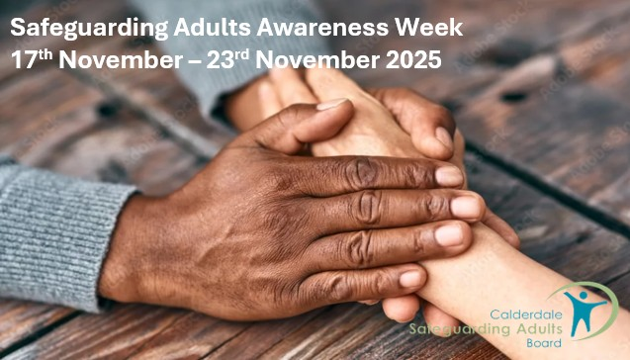

Calderdale Safeguarding Adults Awareness Week

Monday 17th November – 23rd November 2025
Calderdale Safeguarding Adults Board supports the Ann Craft Trust Safeguarding Adults Week by raising awareness of the programme they have available for everyone and also promoting events on offer from Calderdale partners.

Monday 17th November

Ann Craft Trust - Learnings from gambling in sport – sharing support programme and projects – Free Safeguarding Adults Week Online Seminar
Free online seminar for Safeguarding Adults Week from Ara Recovery for All, which provides education, training and treatment services for gambling related harm.
10.30 to 11.30 Virtual
Click to book

Ann Craft Trust - Sexuality & relationships in the lives of adults with learning disabilities – Free Safeguarding Adults Week Online Semina
As part of Safeguarding Adults Week, Ann Craft Trust Safeguarding Adults Manager Laura Thorpe discusses how we can start conversations about sexuality and relationships to prevent misunderstanding and vulnerability.
Ann Craft Trust - A Holistic Approach to the Prevention of Abuse in Sport – Free Safeguarding Adults Week Online Seminar
13.30 to 14.30 virtual
Click to book

Ann Craft Trust - A Holistic Approach to the Prevention of Abuse in Sport – Free Safeguarding Adults Week Online Seminar
Insights from Emma Thomas: Survivor, Researcher, & Sports Ethicist
This seminar draws from Emma’s research to illustrate the importance of a holistic, collaborative and multi-layered approach to the prevention of abuse in sport. Emma will discuss how we can build a culture that has survivors’ wellbeing at its heart.
1600 to 1700 virtual
Click to book

Tuesday 18th November

Safeguarding Adults – Ask me Anything
An ask me anything session with Gemma Stead and Harriet Sykes, Adult Services and Well being, CMBC.
they will talk about responding to concerns as well as what to do if the concern needs a safeguarding referral to be submitted. They will talk through the themes of the more recent Safeguarding Adult Reviews and give people opportunities to ask about any processes and interventions.
10.30 to 12.00 virtual
Book through Enable

Working With Resistance and Professional Curiosity
Delivered by the Safeguarding Partnership
This session covers what is meant by disguised compliance or working with resistance and the importance of relationship building, as well as looking a strategies to support curiosity and managing difficult conversations.
1300 to 1600 virtual
Book through Enable

Ann Craft Trust - Preventing Forced Marriage – Free Safeguarding Adults Week Online Seminar
Understanding and preventing forced marriage of people with learning disabilities.
15.30 to 16.30 virtual
Click to book

Wednesday 19th November

Masterclass on Transitional Safeguarding
Yorkshire and Humber Event – see flyer here
This 3-hour interactive masterclass with Dez Holmes will:
- Clarify what Transitional Safeguarding is, and is not, explore the evidence base and six key principles, share learning from local areas innovating in this space and support participants to consider how this approach could be applied.
0930 to 1230 – virtual
Click to book

Challenges Facing Children and Adults in and Online World
Delivered by David Tidman from InVentry Ltd
In this two hour session we will look into why technology, social media and the internet is so appealing to young and old alike. We will consider how it has become engrained into our lives, why this is the case and the impact it can have. We will consider some of the approaches used by social media companies to keep us engaged and how it is being used to influence our thinking and perceptions of the world
1000 to 1200 – at Halifax Town Hall
Book through Enable

Locala Bitesize Briefing: Homelessness
1400 to 1430 virtual
Join the meeting now
Meeting ID: 371 792 243 231
Passcode: a24iH9u7
Contact claire.nixon@locala.org.uk

Thursday 20th November

Locala - Bitesize Briefing – Raising concerns for adult social care including Making Safeguarding Personal
0900 to 0930 virtual
Join the meeting now
Meeting ID: 382 950 369 027 6
Passcode: Bi2jB6YU
Contact claire.nixon@locala.org.uk

Meet The Teams who Safeguard Adults in Calderdale
Calderdale Safeguarding Adults Board are offering a day to meet the teams and services in Calderdale who contribute towards the wellbeing and protection of adults who may need additional support to live their best lives.
There will be a wide range of stalls to visit where you will be able to pick up literature and ask specific questions from experts in their field, hear about their services and how you can make referrals. With presentations on Making Every Adult Matter, Trauma Informed Practice and Suicide Prevention.
09.30 to 16.00 at Mytholmroyd Community Centre
Book through Enable

Ann Craft Trust - Trust Your Instincts – Physical Abuse and Safeguarding Adults – Free Safeguarding Adults Week Online Seminar
Little research has been done regarding the physical abuse of adults at risk of harm in England, despite this being the second most common type of abuse reported nationally.
11.30 to 12.30 virtual
Click to book

Friday 21st November

Locala - Bitesize Briefing: Non-fatal Strangulation
0930 to 1000 virtual
Join the meeting now
Meeting ID: 376 963 847 424 1
Passcode: 3Dn2nD39
Contact claire.nixon@locala.org.uk
Ann Craft Trust - HeadSAFE Football: Protecting Players, Promoting Safety – Free Safeguarding Adults Week Online Seminar
Join Nick and Lou for an engaging HeadSAFE Football education session designed to raise awareness about player welfare and adult safeguarding in football.
10.00 to 11.00 virtual
Click to book

Ann Craft Trust - Listening to the Voice of Sport Participants – Key Insights – Free Safeguarding Adults Week Online Seminar
In a free online seminar for Safeguarding Adults Week, Anne Patterson will discuss insights from the Listening to the Voice of Participants Project.
13.30 to 14.30 virtual
Click to book

