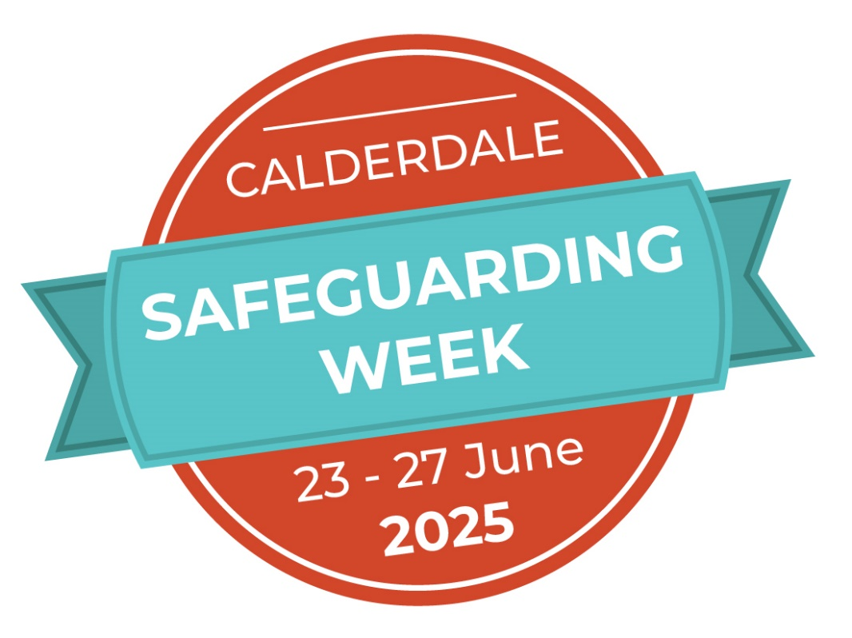

Programme of Events

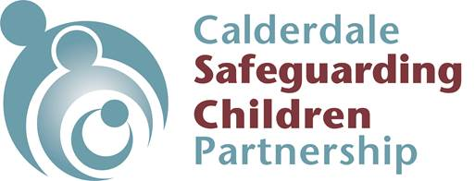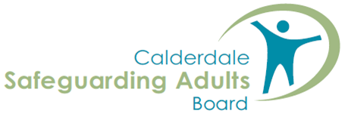

**Welcome to Safeguarding Week 2025!**

The Safeguarding Children Partnership, Safeguarding Adults Board and Calderdale organisations present Safeguarding Week 2025 Programme. The aim is to raise awareness about safeguarding children and adults and the importance that **safeguarding is everyone’s business**.

Calderdale is again, taking part in a West Yorkshire wide Safeguarding Week where each Local Authority will host a day each, to present a topic of their choice and **all** practitioners and managers from across West Yorkshire can attend **any of those** events:

**Monday:** Hosted by Leeds: **Financial Exploitation and Abuse, Child Exploitation – The Rise of AP Parties, County Lines in West Yorkshire, Cuckooing! Its Happening in West Yorkshire**

**Tuesday:** Hosted by Kirklees: **Learning from Safeguarding Adult Reviews, Domestic Abuse Related Death Reviews and Child Safeguarding Practice Reviews**

**Wednesday:** Hosted by Wakefield: **Creating and Inclusive Environment, Pride in Practice: Supporting and Safeguarding LGBTQIA+ Young People, Alcohol Use, Self-Neglect and Barriers to Support; A Spotlight on Steven, Engaging with Men**

**Thursday:** Hosted by Calderdale**: Growing Up is a Process Not an Event: Transforming Transitions, Domestic Abuse and the Adult Child- A Mother’s Story**

**Friday:** Hosted by Bradford: **Exploring the Aspects of Modern Day Slavery, CSE and Missing Children**

Calderdale partners have also offered local events throughout the week, including a varied offer of face to face, and live online learning sessions all aimed at Calderdale practitioners and managers.

If you have any questions about Safeguarding Week, please contact: Sally Fletcher [Sally.Fletcher@Calderdale.gov.uk](mailto:Sally.Fletcher@Calderdale.gov.uk).

Thank you for taking part in Safeguarding Week 2025, and for contributing towards keeping children and adults safe in Calderdale.

***Julia Caldwell***Safeguarding Partnerships Manager, Domestic Homicide Review Lead

Calderdale Safeguarding Adult Board & Safeguarding Children Partnership

 

## Contents

Contents 3

MONDAY 23rd June 2025 4

West Yorkshire Events: Hosted by Leeds 4

Local Live Sessions: 5

TUESDAY 24th June 2025 6

West Yorkshire Events: Hosted by Kirklees 6

Local Live Sessions: 6

WEDNESDAY 25th June 2025 8

West Yorkshire Events: Hosted by Wakefield 8

Local Live Sessions: 9

THURSDAY 26th June 2025 11

West Yorkshire Events: Hosted by Calderdale 11

Local Live Sessions: 12

FRIDAY 27th June 2025 13

West Yorkshire Events: Hosted by Bradford 13

Local Live Sessions: 13

## MONDAY 23rd June 2025

### West Yorkshire Events: Hosted by Leeds

#### Financial Exploitation and Abuse

Delivered by West Yorkshire Police

**Time:** 09.30 to 10.30

**Location:** virtual via Microsoft Teams

**Aim of Session:**

West Yorkshire Financial Exploitation and Abuse Team (WYFEAT) offers a comprehensive training session designed to help you understand and address financial abuse and exploitation. This session delves into how financial abuse is covered under The Care Act 2014 and provides practical measures to safeguard service users from scams and doorstep crime. It includes real case studies from victims in West Yorkshire to illustrate the team's work and emphasizes the importance of changing the stigma associated with being scammed. Additionally, this session explains the role of WYFEAT, the referral process, and the support available to victims.

**How to book**: [Microsoft Virtual Events](https://events.teams.microsoft.com/event/cc5413a5-eb7a-4655-89d2-e1f2bdc9fb0f%4016864fae-286e-4707-a78b-d7188d6149a7) [Powered by Teams](https://events.teams.microsoft.com/event/cc5413a5-eb7a-4655-89d2-e1f2bdc9fb0f%4016864fae-286e-4707-a78b-d7188d6149a7)

#### Child Exploitation – The rise of AP parties

Delivered by Leeds City Council

**Time:** 11.00 to 12.00

**Location:** virtual via Microsoft Teams

**Aim of Session**: Discover what an AP party is and the risks for young people who attend; including: drugs and alcohol, financial exploitation, sexual exploitation and violence.

Find out how speak to young people about the risks, how to make a referral and sharing information with other agencies.

**How to book**: [Microsoft Virtual Events Powered](https://events.teams.microsoft.com/event/b8692154-fcc0-41fc-8042-9c2cd688c9a6%4016864fae-286e-4707-a78b-d7188d6149a7) [by Teams](https://events.teams.microsoft.com/event/b8692154-fcc0-41fc-8042-9c2cd688c9a6%4016864fae-286e-4707-a78b-d7188d6149a7)

#### County Lines in West Yorkshire

Delivered by West Yorkshire Police

**Time:** 13.00 to 14.00

**Location:** virtual via Microsoft Teams

**Aim of Session**: This webinar by West Yorkshire Police will outline what County Lines is, signs and symptoms, the police response, and how people working in the third sector can contribute to combatting it.

**How to book**: [Microsoft Virtual Events](https://events.teams.microsoft.com/event/d8d9d4d3-bc4c-45b9-a536-654a01f886bd%4016864fae-286e-4707-a78b-d7188d6149a7/registration) [Powered by Teams](https://events.teams.microsoft.com/event/d8d9d4d3-bc4c-45b9-a536-654a01f886bd%4016864fae-286e-4707-a78b-d7188d6149a7/registration)

#### Cuckooing! It’s Happening in West Yorkshire

Delivered by Leeds Safer Stronger Communities

**Time:** 14.30 to 15.30

**Location:** virtual via Microsoft Teams

**Aim of Session**: Cuckooing is a form of exploitation where an individual or a criminal gang target the home of a vulnerable person so they can use the property for criminal purposes

In this webinar by Leeds Safer Stronger Communities, you will hear why and how people are targeted, the work going on in W. Yorks to combat cuckooing and how people have been helped to be safe.

**How to book**: [Microsoft Virtual Events](https://events.teams.microsoft.com/event/9b60a583-3a8e-4f36-9293-27c50d6f9cf5%4016864fae-286e-4707-a78b-d7188d6149a7) [Powered by Teams](https://events.teams.microsoft.com/event/9b60a583-3a8e-4f36-9293-27c50d6f9cf5%4016864fae-286e-4707-a78b-d7188d6149a7)

### Local Live Sessions:

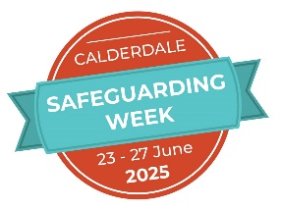

#### Launch of VAC’s Safeguarding Toolkit

Delivered by Calderdale Voluntary and Community

**Time:** 13.30 to 14.30

**Location:** virtual via Microsoft Teams

**Aim of Session:**

Free online session illustrating the new documents and templates freely available to VCSE organisations in Calderdale.

**How to book**: Email [info@cvac.org.uk](mailto:info@cvac.org.uk) Subject Line: Safeguarding Toolkit Launch

Contact information if issue accessing the session on the day: **Charlie Johnston, email** [**charlie.johnston@cvac.org.uk**](mailto:charlie.johnston@cvac.org.uk) **or call 07802 426 688**

**Prevent Training Workshop - The Manosphere, Male Supremacy and Antifeminism**

Delivered by Maeve Park

**Time:** 15.00 to 16.30

**Location:** virtual via Microsoft Teams

**Aim of Session:**

This session will cover key topics, including the demographics of Manosphere groups, influential narratives, vulnerabilities to this form extremism, radicalisation pathways and how these spaces can lead to other forms of extremism.

We’ll explore the radicalisation process, red flags, and potential risks through real-life case studies. Following this workshop participants will gain valuable insight into how people become radicalised into this form of extremism, how to know if someone is at risk and intervention routes and support available.

**How to book**: [through Enable](https://calderdalescp.vc-enable.co.uk/Login/Login?ReturnUrl=%2F)

## TUESDAY 24th June 2025

### West Yorkshire Events: Hosted by Kirklees

### 

#### Learning from Safeguarding Adult Reviews, Domestic Abuse Related Death Reviews, and Child Safeguarding Practice Reviews

Delivered by Kirklees Safeguarding Partnership

**Time:** 13.30 to 14.30

**Location:** virtual via Microsoft Teams

**Aim of Session:** Full details of the reviews that will be covered in this session will be released nearer to the event.

**How to book**: [Microsoft Virtual Events](https://events.teams.microsoft.com/event/90185a22-e5d5-462d-9921-fb7682f8296f%4061d0734f-7fce-4063-b638-09ac5ad5a43f) [Powered by Teams](https://events.teams.microsoft.com/event/90185a22-e5d5-462d-9921-fb7682f8296f%4061d0734f-7fce-4063-b638-09ac5ad5a43f)

### Local Live Sessions:



**Safer Recruitment in the VCSE Sector**

Delivered by Calderdale Voluntary and Community

**Time:** 10.30 to 12.30

**Location:** [VAC](https://www.cvac.org.uk/meeting-room-hire/), Resource Centre, 8 Hall Street, Halifax, HX1 5AY

**Aim of Session:** Face-to-face session looking at best practice around safer recruitment for those in the voluntary sector.

**How to book**: Email [info@cvac.org.uk](mailto:info@cvac.org.uk) Subject Line: Safer Recruitment Training

Contact information if issue accessing the session on the day: **Charlie Johnston, email** [**charlie.johnston@cvac.org.uk**](mailto:charlie.johnston@cvac.org.uk) **or call 07802 426 688**

#### Current Trends and Supporting Young People to Stay Safe Over the Summer

Delivered by Branching Out

**Time:** 14.00 to 16.00

**Location:** The Orange Box, 1 Blackledge, Halifax HX1 1AF

**Aim of Session:** Overview of the current trends around drugs and alcohol and how those working with young people can give basic harm reduction advice particularly focusing on staying safe over summer

**How to book**: [through Enable](https://calderdalescp.vc-enable.co.uk/Login/Login?ReturnUrl=%2F)

Contact information if issue accessing the session on the day: **Rebecca Doyle 07803 414 902 . Hendy Denton 07977 097 057**

**Prevent Training - Online Gaming and Links to Extremism**

Delivered by Calderdale Prevent Team

**Time:** 09.30 to 10.45

**Location:** virtual via Microsoft Teams

**Aim of Session:**

To increase participants awareness of online gaming, gaming-adjacent platforms, and links to extremism.

**How to book**: [through Enable](https://calderdalescp.vc-enable.co.uk/Login/Login?ReturnUrl=%2F)

#### Multi-Agency Preparation for Child Protection Conference

Delivered by Calderdale Safeguarding Partnership

**Time:** 13.00 to 16.00

**Location:** virtual via Microsoft Teams

**Aim of Session:**

This course focuses on preparation for and involvement in the child protection conference process for children where there is reasonable cause to suspect that a child is suffering, or likely to suffer, significant harm and will assist anyone who is likely to need to contribute to a report for and attend an Initial Child Protection Conference or Review.

**How to book**: [through Enable](https://calderdalescp.vc-enable.co.uk/Login/Login?ReturnUrl=%2F)

## WEDNESDAY 25th June 2025

### West Yorkshire Events: Hosted by Wakefield

#### Creating an Inclusive Environment

Delivered by Yorkshire Sporting Foundation

**Time:** 10.00 to 11.00

**Location:** virtual via Microsoft Teams

**Aim of Session:** In this session you will learn how to identify barriers to participation, understand positive action, and create a more inclusive environment that attracts and retains diverse participants and volunteers.

**How to book**: [Yorkshire Sport Foundation:](https://www.wakefieldscp.org.uk/training/course/yorkshire-sport-foundation-creating-an-inclusive-environment-safeguarding-week-2025/) [Creating an Inclusive Environment -](https://www.wakefieldscp.org.uk/training/course/yorkshire-sport-foundation-creating-an-inclusive-environment-safeguarding-week-2025/) [Wakefield Safeguarding Children](https://www.wakefieldscp.org.uk/training/course/yorkshire-sport-foundation-creating-an-inclusive-environment-safeguarding-week-2025/)

#### Alcohol Use, Self-Neglect and Barriers to Support: A Spotlight on Steven

Delivered by Wakefield Safeguarding Adults Board

**Time:** 13.00 to 14.15

**Location:** virtual via Microsoft Teams

**Aim of Session:** Last year, the Wakefield and District Safeguarding Adults Board published an important Safeguarding Adults Review (SAR) about Steven. Steven’s life and early death highlight themes relating to care and support to people with alcohol misuse disorder, but also wider themes associated with people living complex lives.

In this webinar, the Board’s Independent Chair and Business Manager will share the key findings of the SAR for Steven, using it to draw out wider learning for both practitioners and services who support people experiencing alcohol misuse and/or self-neglect.

**How to book**: [Microsoft Virtual Events](https://events.teams.microsoft.com/event/2d643215-270a-4be7-b6cb-28e50152b8af%40d76faab7-96b7-40c7-9b25-3d2fbd4ac1f1) [Powered by Teams](https://events.teams.microsoft.com/event/2d643215-270a-4be7-b6cb-28e50152b8af%40d76faab7-96b7-40c7-9b25-3d2fbd4ac1f1)

#### Pride in Practice: Supporting and Safeguarding LGBTQIA+ Young People

Delivered by Spectrum Health

**Time:** 15.00 to 17.00

**Location:** virtual via Microsoft Teams

**Aim of Session**: Spectrum Health will be delivering this webinar on gender questioning. You will learn how best to support a child in the LGBTQIA+ community. Steph will dispel myths and work with practitioners to help them feel confident in assessing risk and other vulnerabilities when safeguarding LGBTQIA+ children.

**How to book**: [Pride in Practice: Supporting and](https://www.wakefieldscp.org.uk/training/course/pride-in-practice-supporting-and-safeguarding-lgbtqia-young-people/) [Safeguarding LGBTQIA+ Young](https://www.wakefieldscp.org.uk/training/course/pride-in-practice-supporting-and-safeguarding-lgbtqia-young-people/) [People - Wakefield Safeguarding](https://www.wakefieldscp.org.uk/training/course/pride-in-practice-supporting-and-safeguarding-lgbtqia-young-people/) [Children](https://www.wakefieldscp.org.uk/training/course/pride-in-practice-supporting-and-safeguarding-lgbtqia-young-people/)

#### Engaging with Men

Delivered by Wakefield Safeguarding Children Partners

**Time:** 09.30 to 16.00

**Location:** **Pontefract Suite, Wakefield One, WF1 2EB**

**Aim of Session**: With inputs from the Rosalie Ryrie Foundation, Family Nurse Partnership 0-19 Service, Wakefield Parent and Infant Relationship (PAIR) Team and the Dad Matters project from Wakefield Homestart.

This full day session will explore:

* Barriers, biases, and principles of good practice when working with men,

including those that pose a risk.

* Beliefs and understanding from men
* The impact and long-term effects of childhood trauma and behaviours (Meet Charlie)
* Motivational interviewing

**How to book:** [Engaging with Men - Wakefield](https://www.wakefieldscp.org.uk/training/course/rosalie-ryrie-engaging-with-men/) [Safeguarding Children](https://www.wakefieldscp.org.uk/training/course/rosalie-ryrie-engaging-with-men/)

### Local Live Sessions:



#### Meet the Teams who Work Together to Safeguard Children in Calderdale

Delivered by Calderdale Safeguarding Partnership

**Time:** 09.30 to 16.00

**Location:** [The King Centre](https://g.co/kgs/YYDmbNS), Park Road, Halifax, HX1 2TS

**Aim of Session:**

Calderdale Safeguarding Children Partnership presents an opportunity to meet the services in Calderdale who contribute towards the wellbeing and protection of children across the whole continuum of need. You will get to hear about the services they deliver and how you can make referrals.

Through the stalls you will be able to pick up literature and ask specific questions from experts in their field.

This is an excellent opportunity to find out how Calderdale Works Together to Safeguard Children.

**How to book**: [through Enable](https://calderdalescp.vc-enable.co.uk/Login/Login?ReturnUrl=%2F)

**How DBS work with organisations to safeguard vulnerable groups**

Delivered by Calderdale Voluntary and Community

**Time:** 13.00 to 14.30

**Location:** virtual via Microsoft Teams

**Aim of Session:**

Free online webinar delivered live by the DBS Outreach Adviser for Yorkshire & The Humber in partnership with Voluntary Action Calderdale, the session will explore;

* Who DBS are and what we do
* How DBS work with organisations to safeguard vulnerable groups
* DBS checks - the different types and what they can disclose
* How the DBS Update Service supports ongoing safer employment
* Introduction to the DBS Barring functions

**How to book**: Online through the link [Microsoft Virtual Events Powered by Teams](https://events.teams.microsoft.com/event/0db38406-3a58-44d7-ac74-8ffb8e797f75@f24d93ec-b291-4192-a08a-f182245945c2)

Contact information if issue accessing the session on the day: **Charlie Johnston, email** [**charlie.johnston@cvac.org.uk**](mailto:charlie.johnston@cvac.org.uk) **or call 07802 426 688**

## THURSDAY 26th June 2025

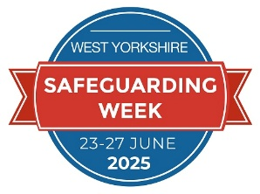

### West Yorkshire Events: Hosted by Calderdale

#### Growing Up is a Process Not an Event: Transforming Transitions

Delivered by Dez Holmes

**Time:** 09.30 to 12.30

**Location:** Virtual via Microsoft Teams

**Aim of Session:**

* Understand what the concept of Transitional Safeguarding is, and what it is not,
* Explore research, practice wisdom and expertise from lived experience to understand why Transitional Safeguarding is needed and how it is the basis of ‘early help for adults’
* Deepen their understanding of Transitional Safeguarding as an issue of whole-system change, and systems leadership
* Hear how other local areas are trying to develop a Transitional Safeguarding response
* Reflect on how Transitional Safeguarding can transform how Calderdale supports young people into adulthood

**How to book**: [**Here**](https://events.teams.microsoft.com/event/f2f2f24c-ff9e-4073-9491-27feb67b6c8b@07162ea2-1b0e-498f-bb55-5b41fd4dce4f)

#### Domestic Abuse and the Adult Child - A Mother's Story

Delivered by Ann Brown

**Time:** 14.00 to 16.00

**Location:** [The Orange Box](https://www.orangeboxhalifax.org/activities.asp.) Young Peoples Centre, 1 Blackledge Halifax HX1 1AF

**Aim of Session:**

Calderdale Safeguarding Partnership invites you to join Ann Brown in a face-to-face discussion where she shares her journey of overcoming domestic abuse and its impact on her children as they grew into young adults. This powerful story sheds light on the long-term effects of abuse and the resilience of survivors. Be inspired, gain insight, and show your support for those who have endured such challenges. This event is a unique opportunity to reflect on your own practices in sustaining support for children affected by domestic abuse as they transition into young adults and beyond.

**How to book**:  [**Here**](https://www.eventbrite.co.uk/e/domestic-abuse-and-the-adult-child-a-mothers-story-tickets-1321126417679?aff=oddtdtcreator)

### Local Live Sessions:



#### Overdose Awareness, Harm Reduction and Naloxone Training.

Delivered by Calderdale Recovery Steps

**Time:** 11.00 to 13.00

**Location:** Martins Room – The Basement Recovery Project, 8 - 10 Carlton Street, Halifax HX1 2AL

**Aim of Session:** To cover basic overdose awareness (drugs and alcohol) and harm reduction for practitioners working with and supporting those who may be at risk.

**How to book**: [through Enable](https://calderdalescp.vc-enable.co.uk/Login/Login?ReturnUrl=%2F)

Contact information if issue accessing the session on the day: **Sam Jones 07793 246 450 / Stu Mapplebeck 07912 225 745**

#### Every Sleep a Safe Sleep

Delivered by Locala

**Time:** 13.00 to 16.00

**Location:** virtual via Microsoft Teams

**Aim of Session:**

* To ensure all frontline workers are equipped with the skills to engage in individualised safer sleep conversations with parents and carers to reduce the risks of sudden unexpected death in infancy (SUDI), in particular where additional vulnerabilities exist
* To introduce the Sudden Unexpected Death in Infancy Risk Minimisation Tool and Safer Sleep Protective Factors Tool

**How to book**: [through Enable](https://calderdalescp.vc-enable.co.uk/Login/Login?ReturnUrl=%2F)

## FRIDAY 27th June 2025

### West Yorkshire Events: Hosted by Bradford

#### Exploring the aspects of Modern-Day Slavery

Delivered by West Yorkshire Police

**Time:** 10.00 to 11.30

**Location:** virtual via Microsoft Teams

**Aim of Session:**

* Understanding Modern Slavery, Human Trafficking and Child Exploitation.
* Exploring how it may present within your clients or case load.
* Exploring the statutory response and how to gain support for potential victims.
* Understanding how to work with potential victims of Modern Slavery and Human Trafficking to ensure trauma informed and safety focused.
* Sharing contacts from around West Yorkshire who can support your victims of Modern Slavery.

**How to book**: [Microsoft Virtual Events](https://events.teams.microsoft.com/event/56258b71-08e8-4a44-8897-0f9b5b884d50%4028b8dfd0-aa16-412c-9b26-b845b9acd1a9) [Powered by Teams](https://events.teams.microsoft.com/event/56258b71-08e8-4a44-8897-0f9b5b884d50%4028b8dfd0-aa16-412c-9b26-b845b9acd1a9)

#### CSE and Missing Children

Delivered by Bradford Children and Families Trust

**Time:** 13.30 to 14.30

**Location:** virtual via Microsoft Teams

**Aim of Session**: This session will focus on:

* Missing themes, and why children run away.
* Reporting strategies and safeguarding planning.
* Exploitation and the correlations.

**How to book**: [Microsoft Virtual Events](https://events.teams.microsoft.com/event/501c8a30-9717-47a1-b486-e80bf6123793%4028b8dfd0-aa16-412c-9b26-b845b9acd1a9) [Powered by Teams](https://events.teams.microsoft.com/event/501c8a30-9717-47a1-b486-e80bf6123793%4028b8dfd0-aa16-412c-9b26-b845b9acd1a9)

### Local Live Sessions:



#### Lunch and Learn – Adult F

Delivered by Calderdale Safeguarding Partnership

**Time:** 12.15 to 13.00

**Location:** virtual via Microsoft Teams

**Aim of Session:** A briefing on the Safeguarding Adult Review into the death of a lady where there were concerns for self-neglect and domestic abuse.

**How to book**: [through Enable](https://calderdalescp.vc-enable.co.uk/Login/Login?ReturnUrl=%2F)