My Feelings Colouring Chart Guidance

My Feelings colouring chart is a direct work tool (next page) which can help children and young people talk about their feelings about different areas of their life. Direct work is really important when assessing neglect as it can help children communicate, feel listened to, and build their self-esteem.
How to use the tool:  Ask the child to colour in the sections of the chart which represent their feelings – happy, sad or average – for each area of their life  Encourage the child to talk about their choices, ensuring you use open questions and not leading ones. For example – “why do your friends make you happy?” “What is it about school that makes you feel sad”.  Use the opportunity to have a wider discussion about the areas of the child’s life. If they have chosen a sad face, ask if they would want to change anything to make it better.  Record what the child says in their own words on the recording sheet. At the end, ask them how happy they are on a scale of 0- 10 and why.  The child’s wishes and feelings can be used to speak to parents about any concerns (where it is safe to do so) as well as to inform any assessments or plans that are ongoing.  Be creative and adapt the activity to suit the child’s interests, age,  abilities and needs. | Ideas for questions to support direct work activities.  - What do you like best about being at home?  - Tell me about where you live.  - What do you like to do with your friends?  - What do you like to do with your family?  - What are your favourite subjects at school?  - Who lives in your home?  - What would you change about school?  - Tell me what you are good at.  - What do you like best about yourself?  - What do you like to do at the weekend?  - What places do you like to visit?  - Tell me more about your family.

How happy are you? Name:……………………… Age:……
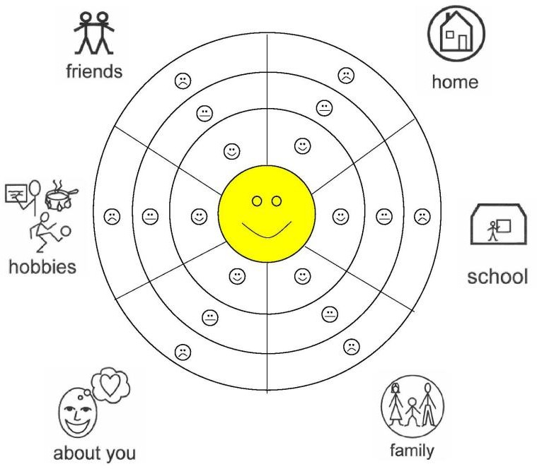

Form for practitioner to record child’s views and feelings
For each area - are you generally happy, sad or somewhere in between? What makes you feel like this? What could be better?

Home | School | Family
About You | Hobbies/Interests | Friends
Overall, how happy are you on a scale of 0-10 (10 is as happy as you can be)?

0 | 1 | 2 | 3 | 4 | 5 | 6 | 7 | 8 | 9 | 10

