Ecomap Guidance

Like a Genogram, an Ecomap is a visual representation of a family. However, instead of just relatives, an ecomap depicts all social and personal relationships and how important these are to the family/child. This is a good way to learn about a family and to understand their support network. Completing an ecomap activity with a family can also help us understand which relationships are difficult for families and where any gaps in support may be.
Usually the child or family is in the centre of the page and circles are drawn to represent the systems around the family – these can be personal or professional relationships. Lines are drawn to identify the status of the relationships, for example if this is strong or weak.
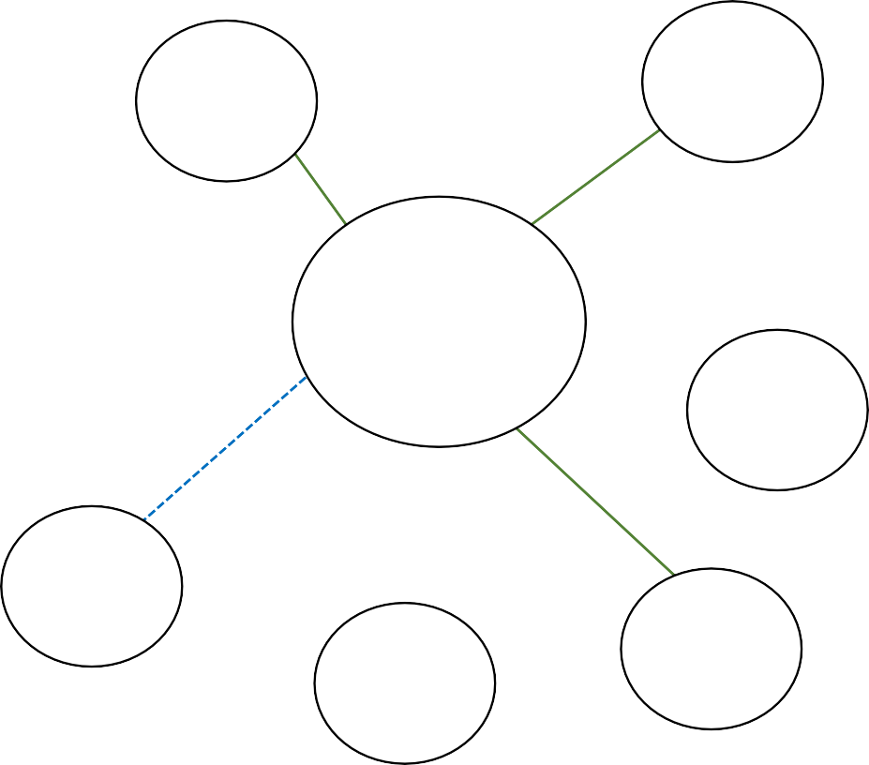
Example Ecomap:
Key to relationships:
Strong
Weak

Stressful
Broken

Neighbours
– Amy & Sam

Health Visitor - Kate

Chloe’s
school

Charlie’s
school

FAMILY
Sophie, 31
Jamie, 38
Chloe, 13
Charlie, 10
Jack, 2
Paternal aunt
Emma Maternal
grandfather Steve

Examples of connections:
Extended family Friends Neighbours Work
School Nursery
Health professionals Voluntary organisations Faith community Sports clubs Hobbies/interests Community groups Social Worker Probation
Support services eg substance misuse, mental health Counsellor/therapist

Maternal grandmother Jane

IDVA -
Aisha

Children’s Centre worker - Yasmin

Early Help Worker - Mark

Ecomap Template

