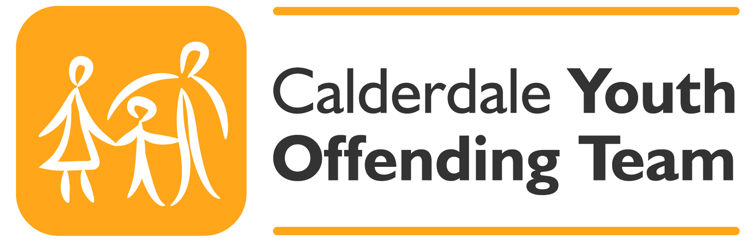

Calderdale Child and Young Persons Harmful Sexual Behaviour Screening Tool

This harmful sexual behaviour (HSB) screening form should be completed when there are concerns regarding inappropriate, problematic or harmful sexual behaviour for young people 12 - 18 years of age.
Child’s full name |  |  |  |  |  |  |  |  |  |  | Alias
DOB |  | Age |  |  |  |  |  |  | Gender M/F
Ethnicity |  |  |  |  |  |  | Religion
Is English their first language? | Child |  | Yes |  |  |  |  |  |  |  |  | No
 | Parent/Carer |  | Yes |  |  |  |  |  |  |  |  | No
If no, please specify preferred language |  |  |  |  |  |  |  |  | Is an interpreter required? Y/N
Address and postcode |  |  |  |  |  |  |  | Contact number(s)
School (if known)
Other children (under 18 years of age) in household | Full Name |  |  |  | Date of Birth/Age |  |  |  |  | Gender M/F |  |  |  | Relationship to the above child
Details of Parent/Carers and other significant adults in household | Full Name |  |  |  | Date of Birth (if known) |  |  |  | Parental Responsibility  (PR) Y/N |  |  |  |  | Relationship to the above child
Other agency/professional involvement
GP details and contact number (if known)

Professional Completing the HSB Screening Tool

Name
Job Title/Role
Agency
Address & Contact Details
Date Assessment commenced |  | Date assessment completed |  | Initial/Review  Assessment ?

Professional Assessment Guidance

This screening form draws from the AIM2 and ERASOR assessment tools to be used by suitably trained professionals. AIM2 is designed for males aged 12-18 years of age. ERASOR assessment tool is designed for use with males or females aged 12- 18 years of age. AIM2 and ERASOR are designed to be used only for those individuals who have previously committed a sexual assault on one or more occasions. The assessment tools are not designed or tested to use for children under 12 or those with a learning disability.
- In completing this form please specify whether fact or a suggestion
- Specify the time when the behaviour occurred – last month, last year etc
- Evidence should list where the information was obtained (Police, Parent, Young Person etc)
- Provide the age(s) of the victim

(1) Risk Indicator - Family and Peer Relationships
Spent their early years or most of their life in a highly dysfunctional family | Yes No Not Known
Pattern of discontinuity of care | Yes No Not Known
The most significant adults in the young persons life have a history of not addressing their own traumas/problematic behaviours | Yes No Not Known
Witnessed domestic violence | Yes No Not Known
Experienced significant physical, emotional, sexual abuse or neglect | Yes No Not Known
The most significant adults in the young persons life express anger or blame the victim(s) | Yes No Not Known
The most significant adults in the young person's life deny, minimise or justify the index offence | Yes No Not Known
The young person is currently experiencing a life crisis such as family rejection or death of a significant family member | Yes No Not Known
Family members do not support or actively undermine professional intervention | Yes No Not Known
Local community is hostile to the young person | Yes No Not Known
Current carers are not supportive of professional intervention | Yes No Not Known
Evidence

(2) Risk Indicator – Health Static
There is early evidence of severe non sexual behavioural problems ( pre 10 years) | Yes No Not Known
Ever had a diagnosis or ADHD | Yes No Not Known
Has a formal diagnosis of Conduct Disorder | Yes No Not Known
(2) Risk Indicator – Health Dynamic
Generally highly impulsive/compulsive | Yes No Not Known
Has difficulty emotionally regulating | Yes No Not Known
Uses substances | Yes No Not Known
Exhibits pervasive anger | Yes No Not Known
Experienced trauma (PTSD) | Yes No Not Known
Evidence

(3) Risk Indicator - Non Sexual Behaviours
History of aggressive behaviour | Yes No Not Known
History of cruelty to animals | Yes No Not Known
Young person has abused or attempted to abuse another person in their current living environment | Yes No Not Known
Previous non-sexual offences | Yes No Not Known
Peer group is predominately pro-criminal | Yes No Not Known
Poor assertiveness skills | Yes No Not Known
Distorted self image | Yes No Not Known
General social isolation | Yes No Not Known
Identifies with younger children | Yes No Not Known
There has been a recent escalation in the young person's aggression or hostility towards others | Yes No Not Known
Previous drop out from treatment programmes to address abusive behaviours | Yes No Not Known
Previously been sanctioned for sexually abusive behaviour | Yes No Not Known
Non compliance towards supervision | Yes No Not Known
Previously been excluded from school | Yes No Not Known
Young person currently has little daily structure or pro-social activities | Yes No Not Known
Evidence

(4) Risk Indicator – Sexually Abusive Behaviours Static
Problematic sexual behaviours commenced pre puberty and continued into adolescence | Yes No Not Known
Evidence of previous contact /non contact sexually abusive behaviours (including previous convictions or admissions) including voyeurism, exhibitionism | Yes No Not Known
Previous allegations of sexually abusive behaviours (but no conviction or admission) | Yes No Not Known
Sexually abused a stranger | Yes No Not Known
Used or threatened violence during a sexual assault | Yes No Not Known
Sexually abused 2 or more victims | Yes No Not Known
Sexually abused males | Yes No Not Known
Abusive behaviour included penetration or attempted penetration | Yes No Not Known
Abused one or more victims on more than two occasions | Yes No Not Known
Offence(s) appear(s) based on grievance or revenge | Yes No Not Known
Problematic sexual behaviours commenced pre puberty and continued into adolescence | Yes No Not Known
Unusually frequent masturbation/sexual thoughts/use of pornography | Yes No Not Known
(4) Risk Indicator – Sexually Abusive Behaviours Dynamic
Has sadistic or violent sexual thoughts | Yes No Not Known
Has self-reported a sexual interest in children | Yes No Not Known
Has beliefs that minimise or support sexually abusive behaviours | Yes No Not Known
Has obsessive/ is preoccupied with sexual thoughts /pornography | Yes No Not Known
Evidence

Mirelle Cigan
Operations Manager
19 June 2018

