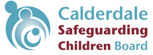
Thresholds Tool
Following assessment, of all the risks and unmet needs for a child, this Thresholds Tool is designed to guide you to the most appropriate referral route by estimating:

What’s the worst that could happen?
• How severe might the consequences be (in terms of impact on the child) on a scale of 1 to 5? (Severity)
• How likely/probable is that to happen on a scale of 1 to 5? (Likelihood/Probability)
• What is the score of severity multiplied by likelihood/probability?

As a multi-agency group, the professionals involved will need to have analysed the information to consider and determine the severity and likelihood/probability of each identified need or risk. This will involve discussing and arriving at a shared understanding of SEVERITY, LIKELIHOOD/PROBABILITY, IMPACT ON THE CHILD. The compilation of a multi-agency chronology as part of the assessment process will help to identify evidence and assist this discussion. The group should score the severity of potential impact on the child on a scale from 1 to 5. The likelihood/probability of the need not being met or risk occurring should be scored on a scale from 1 to 5. Multiply the likelihood/probability by the severity score. This will result in a score which indicates the level of risk.

 | Severity | Description
1 | Insignificant | None or insignificant injury, illness or harm
2 | Low | Minor accident, injury, illness or harm; needs minor treatment or support
3 | Medium | Harm including emotional, injury or illness; needs ongoing treatment or intervention
4 | High | Major injuries or harm including emotional harm/ incapacity
5 | Catastrophic | Fatality / severe incapacity
Use this table to help you to define ‘severity’.

Use this table to plot the likelihood/probability and severity (impact) of harm/unmet need
 | SEVERITY
LIKELIHOOD/ PROBABILITY | Insignificant | Low | Medium | High | Catastrophic
Very unlikely | 1 | 2 | 3 | 4 | 5
Unlikely | 2 | 4 | 6 | 8 | 10
Possible | 3 | 6 | 9 | 12 | 15
Likely | 4 | 8 | 12 | 16 | 20
Very likely | 5 | 10 | 15 | 20 | 25
Once the score has been entered into the table, the result will indicate the threshold at which the case can be managed.

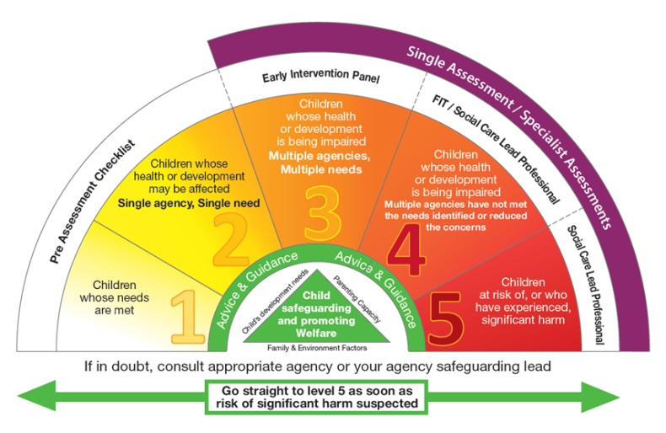
- 0-6 could be managed by Universal or Targeted Services and Early Intervention Services at the higher end - something that’s very likely to happen but insignificant or could be catastrophic but is very unlikely/very improbable.
- 6-12 could suggest it’s more appropriate to manage at Tier 3 of the Continuum of Need with support from the Early Intervention panel and Child in Need at the higher end - the impact could be catastrophic but unlikely to happen, or it may be very likely/ very improbable to happen but comparatively low in impact
- 15 suggests the concerns should be discussed with Children’s Social Care or other appropriate specialist agency (such as CAMHS) to decide the best course of action for the child - ranging from medium risk but very likely/probable or something that would be catastrophic and has a possible chance of happening.
- 16 and over indicates a referral to Children’s Social Care, or other appropriate specialist agency (such as CAMHS)

NB: the severity of the potential consequences or impact will stay the same, but the likelihood/probability can reduce if appropriate safety control measures are put in place, or can increase if there is a change in the circumstances or people involved.

The SMART plan which is produced from assessment and analysis should include actions to reduce the likelihood/probability of the harm occurring. This tool can be used again at a later date to review what impact the SMART plan has made by re-assessing the level of risk. The updated risk level assessment makes it simple to consider if the plan has been effective and the decision whether to continue with the plan is more straightforward, along with deciding whether to make any changes to the plan.

